Exercício 1

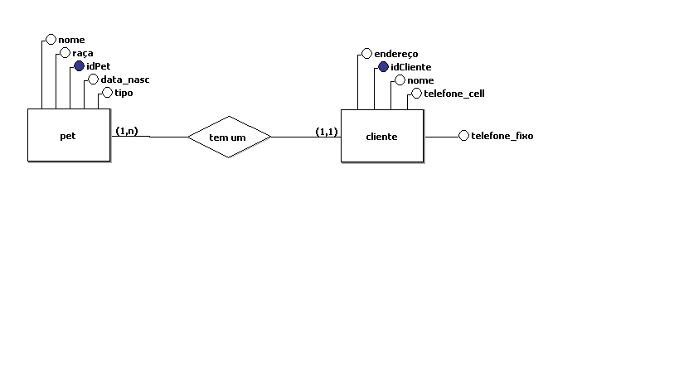

Select * from pet;

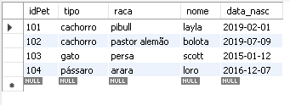

Select * from cliente;

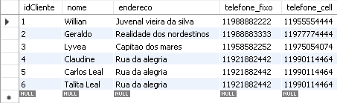

Desc cliente;

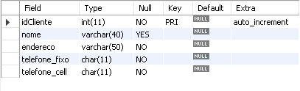

select * from pet where tipo = 'cachorro';

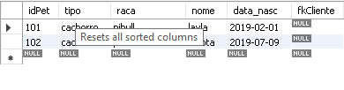

select nome, data_nasc from pet;

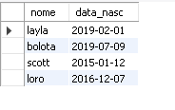

select * from pet order by nome asc;

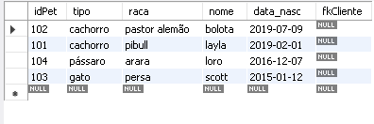

select * from cliente order by endereco desc;

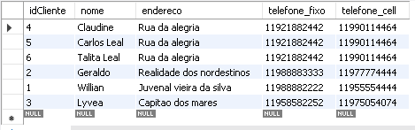

select * from pet where nome like 'l%';

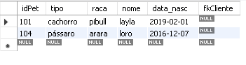

select * from cliente where nome like '%Leal';

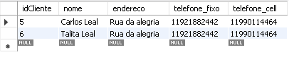

select * from cliente;

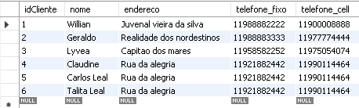

select * from pet, cliente;

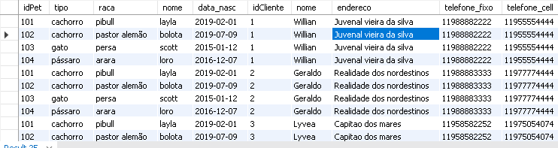

select * from pet, cliente where idCliente = 1 and idPet='102';



delete from pet where idPet = 101;

select * from pet;

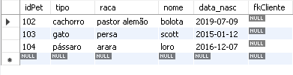

Exercício 2

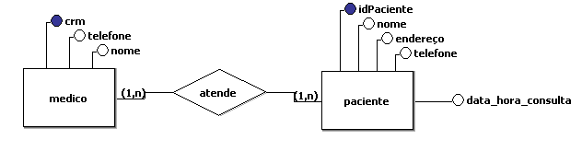

Exercício 3

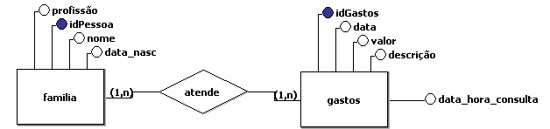

select * from gastos;

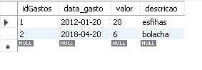

select * from pessoa;

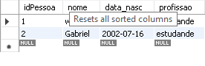

select profissao from pessoa;



select * from pessoa, gastos where idPessoa = 1 and idGastos='1';

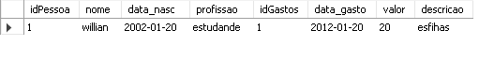

select * from gastos;

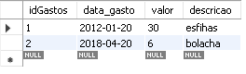

select * from gastos;

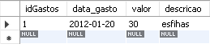

Exercício 4

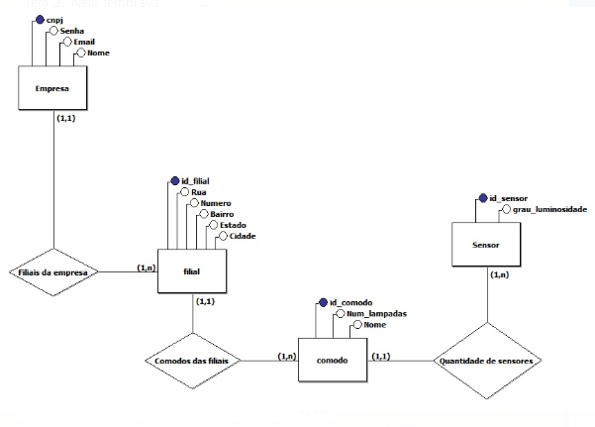

select * from empresa;

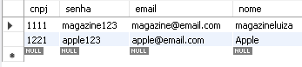

select * from filial;

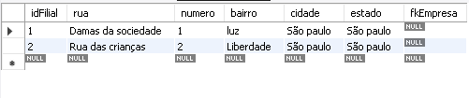

select * from comodo;

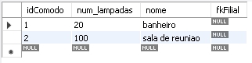

select * from sensor;

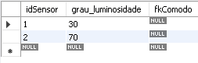

select * from empresa where nome = 'Apple';

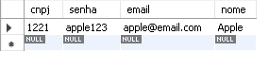

select * from filial where numero = '1';



select * from comodo where nome = 'banheiro';

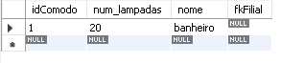

select * from sensor where idSensor = '1';

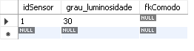

select * from empresa, filial;



select * from comodo, sensor where idComodo = 1 and idSensor='1';



select * from empresa;

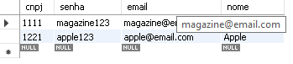

select * from empresa;

